**NAME: GAURAV AMARNANI.**

**ROLL NO. 67.**

**DIVISION: D7A.**

**Python Assignment No. 1**

1. **Consider the variables a and b. Values of a and b are (Roll No. + 15) and (Roll No.+ 2) respectively. The remainder is:**

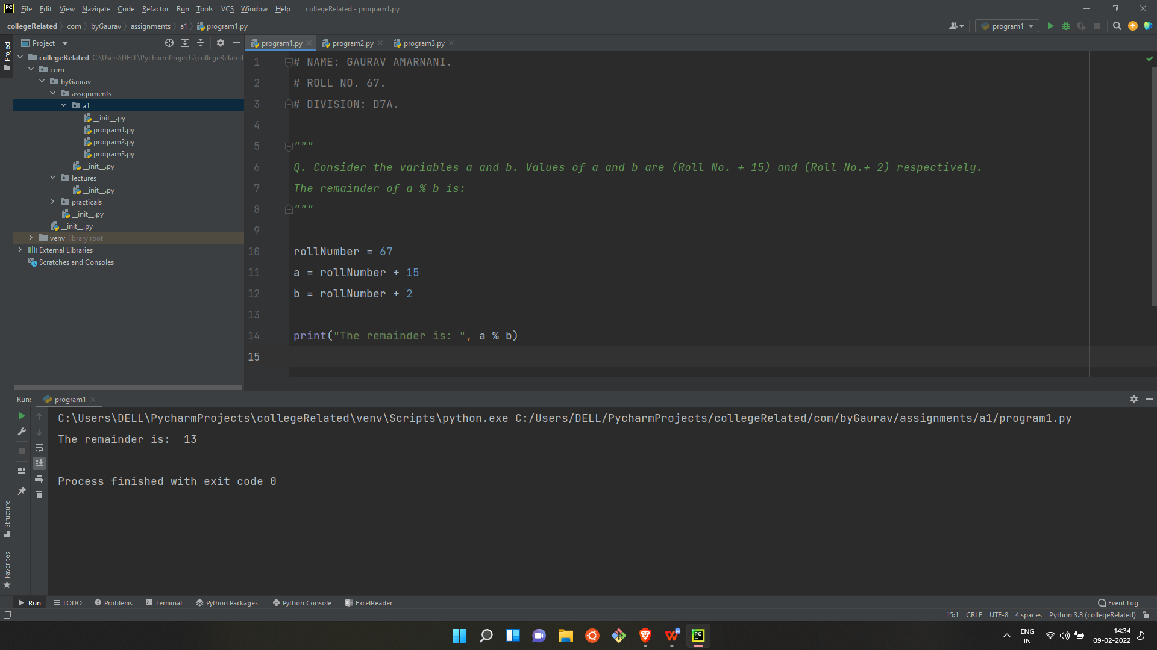

**2. The values of variables p and q are (Roll No * 15) and (Roll No * 3) respectively. What is the value of ‘p’ after running the code as: p*=q**

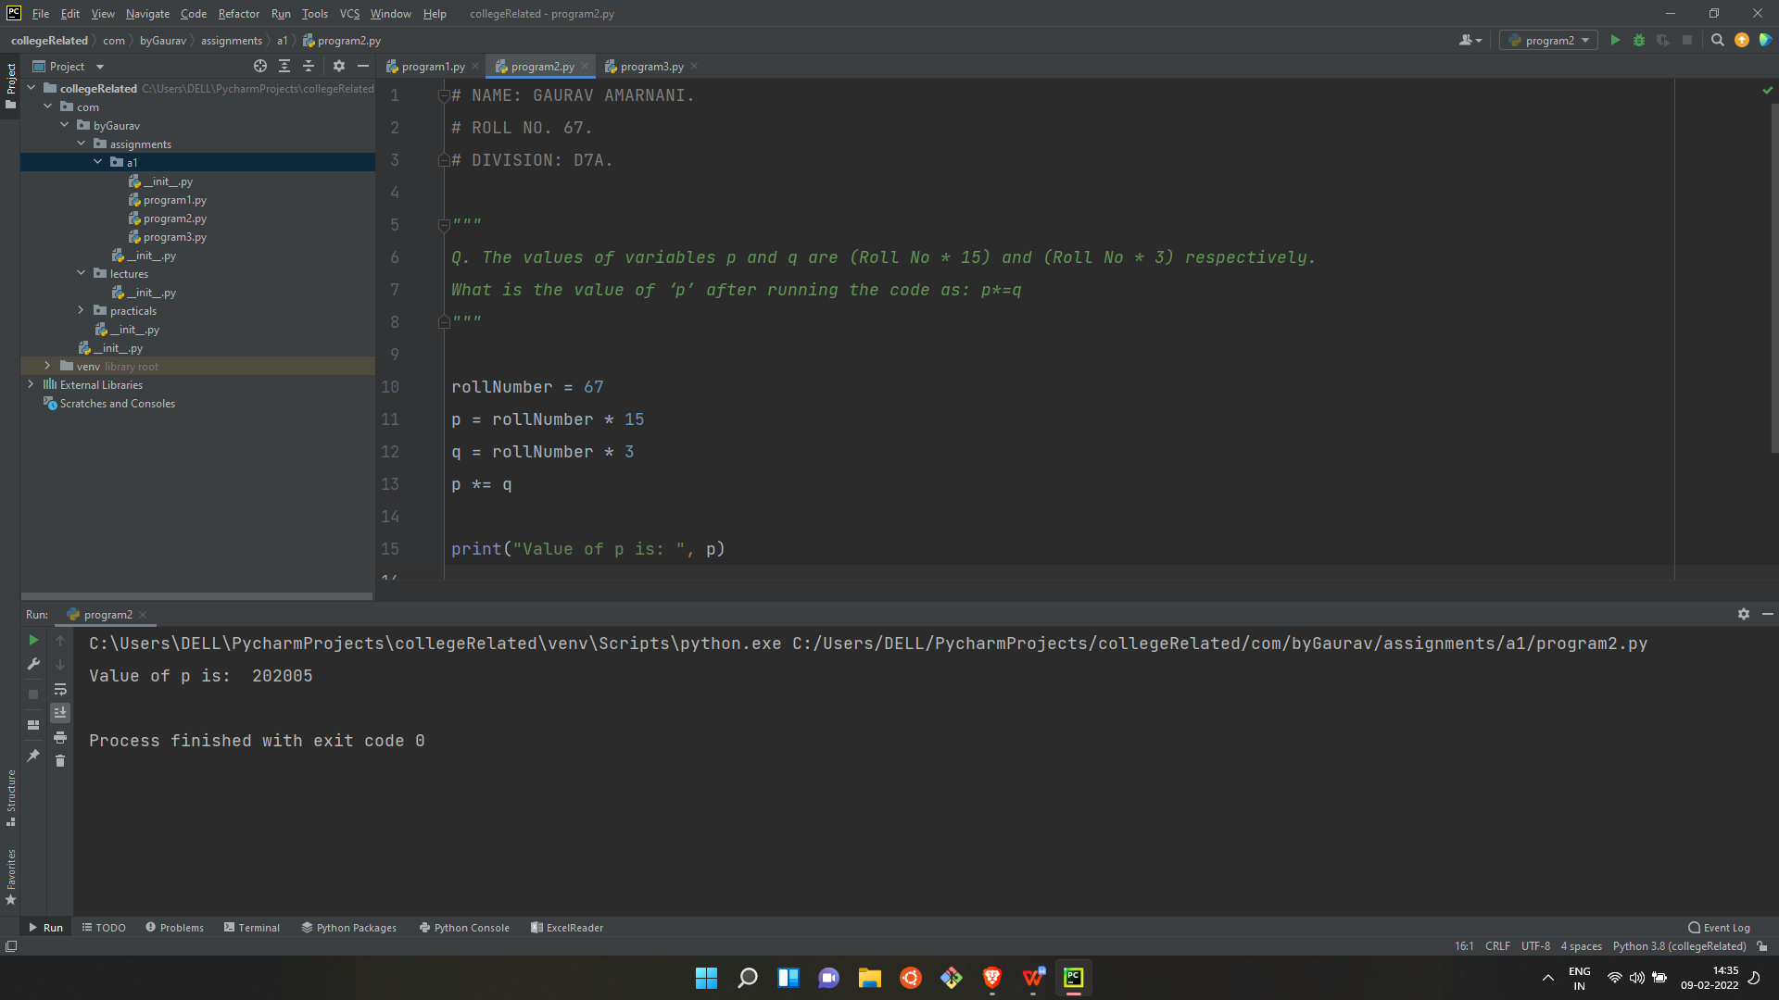

**3. What will be the output after the following statements are executed?**

**X=300 – Roll No.**

**Y= 17 + Roll No.**

**X%=Y**

**print(X)**

